|  |
| --- |
| Compliance Tracker system |
| USER MANUAL |
| [Type the abstract of the document here. The abstract is typically a short summary of the contents of the document. Type the abstract of the document here. The abstract is typically a short summary of the contents of the document.] |

2/4/2020

Table of Contents

Version and Approvals 1

Document Approval 2

Compliance Login 3

How to login 3

How to reset password 3

Compliance system: Home page 4

Tax compliance form 5

Compliance system: Report Pull/Retrieved data 6

## Version and Approvals

**UTORS**

|  |  |
| --- | --- |
| **Version History** | |
| **Version #** | **Date** | | **Revised By** | **Reason for change** |
| **1** | **03 Feb 2020** | |  |  |
|  |  | |  |  |
|  |  | |  |  |
|  |  | |  |  |

## Document Approval

|  |  |
| --- | --- |
| **Document Approvals** | |
| **Approver Name** | **Project Role** | | **Signature/Electronic Approval** | **Date** |
| **Prasad Kale** | **Project Manager** | |  |  |
| **Duma Mseleku** | **Project Developer** | |  |  |
| **Mogale Moseri** | **Project Developer** | |  |  |
| **Siyanda mhlongo** | **Project developer** | |  |  |
| **Chelhango, Lydia** | **Database developer** | |  |  |
| **Crown Ndlala** | **Database developer** | |  |  |
| **Paul Mekgoe** | **Tester** | |  |  |

## Compliance Login

## 

## How to login

* Above is the login page for compliance system. In order to access compliance system user will have to login first. User will enter staff ID, Password and click login button. If invalid Staff ID and Password is entered the user will be denied the access to the system. After entering the valid credentials, a user must click Login button and will be logged in and have all the right granted to that user.

## How to reset password

* In order to reset password, user will navigate to click here to reset password. A user will be able to retrieve password in case the user forgot password using a link Click to reset.
* The form will pop up where the user will be asked for an email address then click send button. And an email with instruction will be received by the user to reset/change her/his password.
* The user’s credentials are stored into a database and validated to check if the user exists in the database.

## Compliance system: Home page

After logging in, a user will be presented with the following screen. Below is the home page of compliance system where users will be able to perform many tasks.

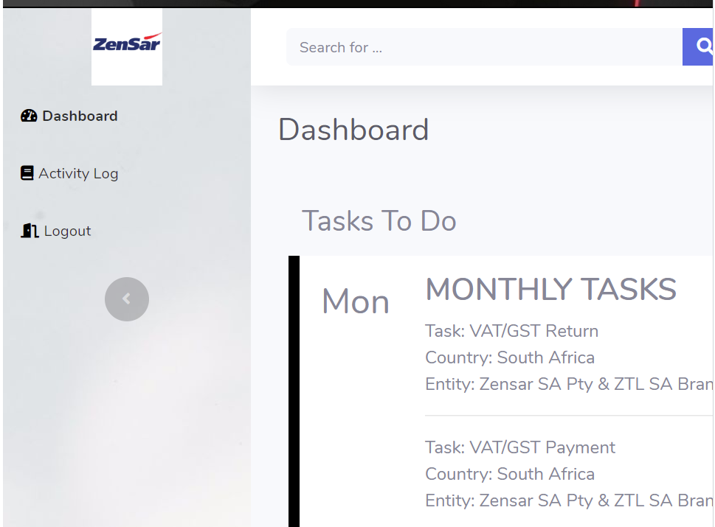

## Tax compliance form

Tax Form able a user to capture the entire task

When user is done capturing the tasks must press submit compliance item button

After submitting a form, information is saved into tax table in the database tax compliance using this query insert into tax (column names) values (columns names)

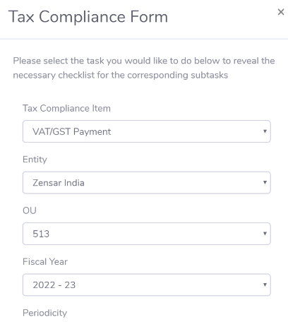

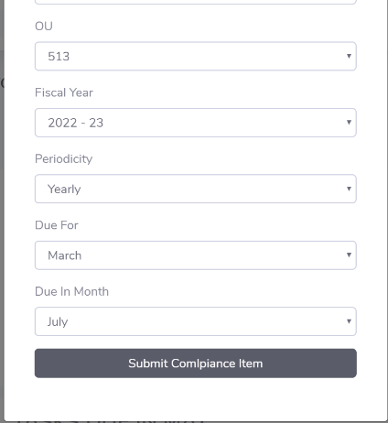

## Compliance system: Report Pull/Retrieved data

Below attached screen shot display data in a table format using JQuery data tables.

Information displayed on the data table is been retrieved form the database called Tax Compliance.

The following sql query is used to pull the data from tax compliance database Select * from tax.

Tax is a table name into the tax compliance database * means all.

The data tables allows users to choose how many entries to display on the table at that time using show drop down box on the top left,

Users will able to navigate/move from one page to another using the pagination. Using first, previous, next and last on the bottom of right hand side.

A user must able to search information from database using a search function from the Tax table using column names

Users will able to see how many entries are in the table tax

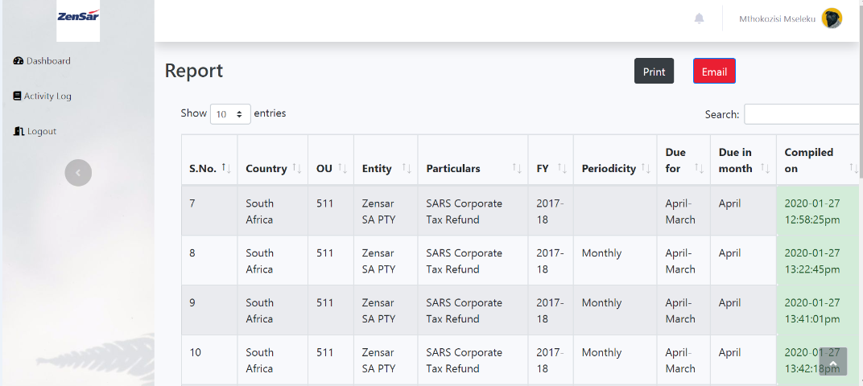

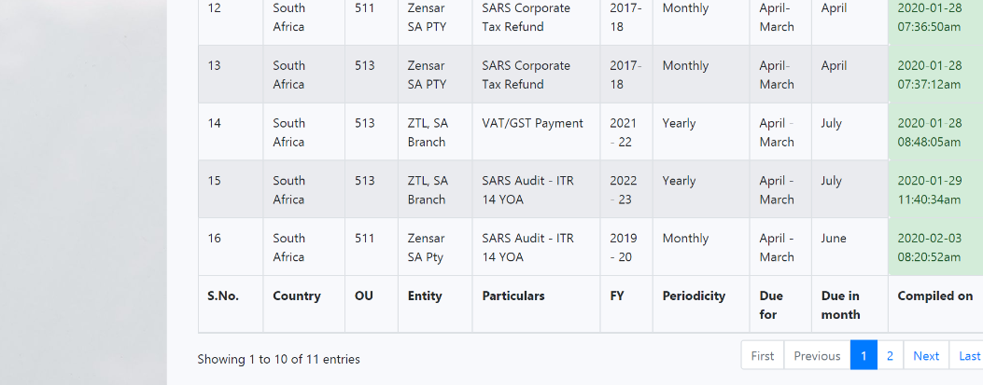

Compliance system: Report